**Docker Case Study 4**

**Code Files:**

1. mksdeploy.yaml (for Kubernetes cluster)

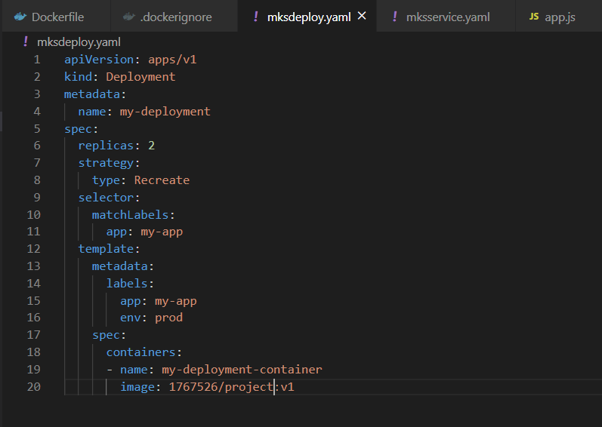

1. mksservice.yaml (for Kubernetes cluster)

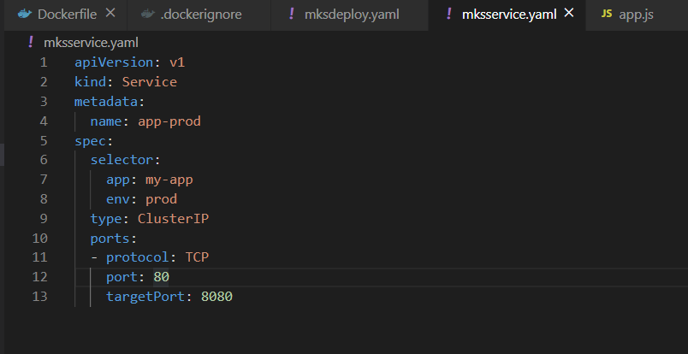

**Commands:**

1. Create Kubernetes cluster (for this example using Azure Kubernetes cluster)
2. Firstly, deploy deployment yaml file and then service yaml file

$: ***kubectl apply -f mksdeploy.yaml***

$: ***kubectl apply -f mksservice.yaml***

**Note: Currently in this example I have used 1 node Kubernetes cluster as 2 nodes don’t come in free tier and I’m using AZURE Kubernetes cluster. But for 2 node cluster procedure is exact same just need to change count and the output for commands “kubectl get services app-prod” & “kubectl get nodes” will be 2 entries instead of 1 which is currently present.**

**Please It’s a request accept this 2-node cluster setup. Because its exact same as 3 node setups.**

**Screenshots:**

